**Mr SGs Electricity Notes**

**Electrical charge**



-Charge is the property of matter responsible for electrical effects

-Protons have a positive charge, electrons have a negative charge and neutrons are uncharged

-Protons and electrons are said to be **charge carriers**

-Charged particles experience the electrostatic force, one of the four fundamental forces of nature that can act at a distance

-Like charges repel each other while unlike charges attract each other

-Atoms are held together by the electrostatic attraction between negatively charged electrons in the electron cloud and positively charged protons in the nucleus

**Net charge**

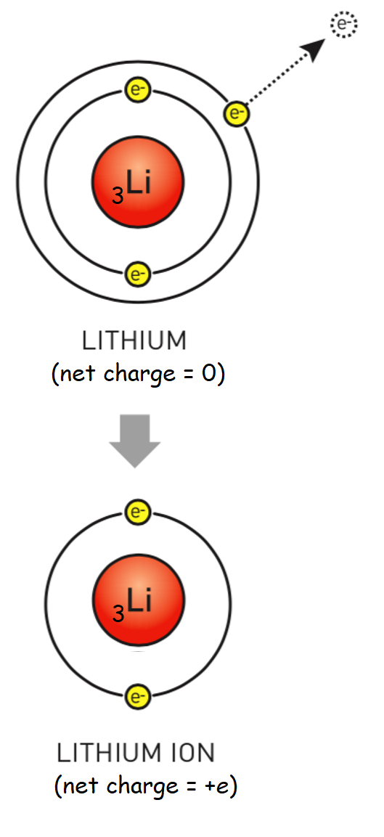

-The charges of protons and electrons are equal in magnitude but opposite

-A proton is said to have a charge of +*e* and an electron has a charge of -*e*

-While a neutral atom contains charged particles, it has no **net charge**, as it has the same number of protons and electrons (e.g. a neutral carbon atom has 6 protons and 6 electrons giving a net charge of +6*e* + (-6*e*) = 0)

-While protons can only be removed from an atom in a nuclear reaction, electrons can move from one atom to another in some circumstances

-The atom losing (negatively charged) electrons becomes positively charged and the atoms gaining electrons become negatively charged

-These charged atoms are said to have been **ionised**, and are referred to as **ions**

**Measuring charge (q)**

-In Physics, the letter q is used to represent charge

-The fundamental charge is that of a proton or electron (*e* or *-e*)

-In practice, this is rarely used as this fundamental charge is incredibly small

-The SI unit of charge is the **coulomb (C)**, which has a charge equal to that of 6.2 x 1018protons

**Electron charge *= -e* (shown as *e* in data sheet) = -1.60 x 10-19 C**

**Charge transfer: conductors & insulators**

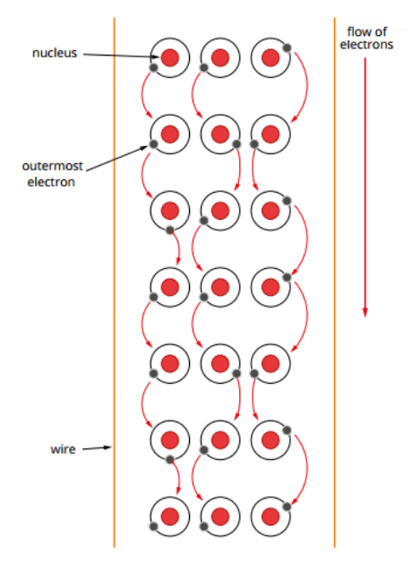

-An atoms outermost electrons are located far from the nucleus

-In metals, these outermost electrons are only loosely held, so they can be transferred between atoms and move freely throughout the material

-These electrons are said to be delocalised, as they are not located on any single atom

-In non-metals, the electrons are held much more tightly and are unable to move between atoms

-As electricity results from the movement of charge, materials like metals are good **conductors** of electricity, and non-metals are poor conductors (**insulators**)

-When charge is transferred from one object to another, it causes the build-up of **static electricity**, which can be discharged as a spark

-When charge flows in an electrical circuit, it results in an **electric current**

**Electrical energy & potential difference**

**Energy in circuits**

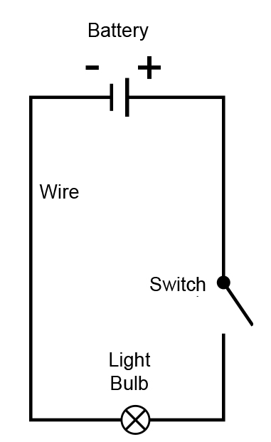

-Electrons must be provided with energy in order to move through a circuit

-When a battery is used to power a circuit, a chemical reaction takes place which causes electrons to be pushed from the positive to the negative terminal of the battery

-The separation of charge produces an electric field around the terminals

-Potential energy known as which electrical energy is stored in this field

-When the terminals of the battery are connected to a circuit, the field moves through the circuit at the speed of light (even though individual electrons travel much more slowly)

-The field the electrons to move through the circuit, transferring this electrical energy to components within the circuit (e.g. a light globe etc)

-Devices within the circuit transform electrical energy into other forms (e.g. a light globe transforms electrical energy into heat and light)

**Potential difference (V)**

-When the chemical reaction in a battery takes place, it causes the separation and build up of charges at the terminals

-This results in a difference in potential energy between the terminals of the battery

-This potential energy difference is what provides the energy to a circuit, so that electrons can move through the circuit transferring energy to the circuit’s components

-**Potential difference** is defined as the amount of electrical potential energy provided to each unit of charge

-It has units of volts (V), where 1 V = 1 J C-1

**V = E** where V is potential difference (V),

**q** E is electrical energy (J) and q is charge (C)

**Measuring potential difference**

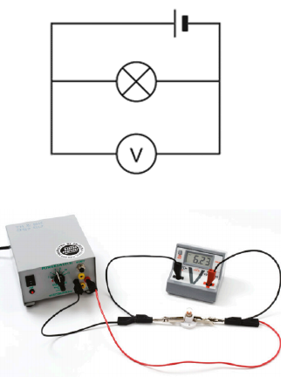

-Potential difference is measured using a voltmeter (or a multimeter in its voltmeter setting)

-It can be used to measure the potential difference across the terminals of a battery (e.g. measure the energy provided to each coulomb of electrons by the battery)

-It can also be used to measure the voltage drop across a component (e.g. the amount of energy that each coulomb of electrons provide to the component as electrical energy is transformed into other types of energy)

-A voltmeter must be connected in parallel to a component, with one voltmeter wire connected to the circuit immediately before the component and the other wire connected directly after the component

-This is because the voltmeter is measuring the difference in the energy that electrons have between two different points of the circuit

**Electrical current/ electrical circuits**

**Circuits**

-An electric circuit is a path made form a conductive material (e.g. copper wire) through which charges can flow in a closed loop

-In almost every circuit, these charges are the delocalised electrons from the metal that makes up the wires

**Electric current:** the flow of charged particles

**Electron flow:** the movement of electrons

-While the electric field that provides energy to charges moves through a circuit at the speed of light, the charges themselves move much more slowly (e.g. a few mm min-1)

-Current can only flow in a circuit when it has an unbroken path to flow around (e.g. all switches are closed etc.)

-It also needs a potential difference present to create the electric field that induces the current

**Circuit diagrams and components**

-Electrical circuits can be incredibly complex, such as those found in appliances, automobiles and other devices

-Rather than attempting to draw detailed pictures of the components in a circuit, simple symbols are used

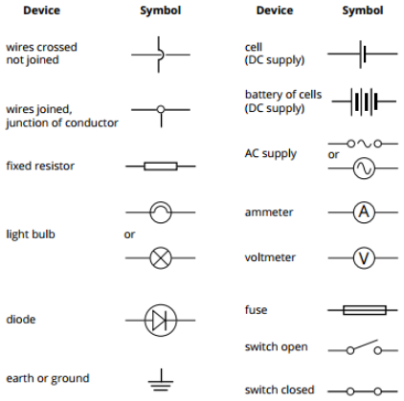

-Circuit diagrams use these symbols to represent electrical circuits

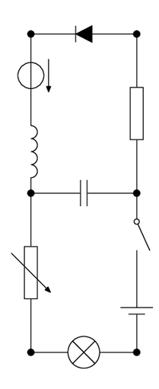



**Conventional current (I) & electron flow**



-When scientists first studied electric circuits, it was assumed that the charges moving through the circuit were positive

-As such, current (I) was assumed to flow from the positive terminal of a battery to the negative terminal

-We still use this convention of showing current (sometimes referred to as conventional current) as the movement of positive charge from the positive terminal of a battery through the circuit to the negative terminal

-This is not strictly correct in most cases, as the charge carriers in most circuits are electrons, which are negatively charged and flow from negative to positive

-In reality, it does not matter whether we consider current as the movement of positive charge rather than negative, as movement of a given amount of positive charge in one direction has the same effect as the movement of the same amount of negative charge in the opposite direction

**Quantifying current**

-Current is a measure of the number of charged particles flowing past a point in the circuit per unit of time

-It has units of amperes (A), where 1 A = 1 C s-1

**I = q** where I is current (A), q is charge (C)

**t** and t is time (s)

-In electrical circuits, electrons are the flowing charge carriers, so the charge can be calculated by multiplying the number of electrons (ne) by the charge of an electron (qe)

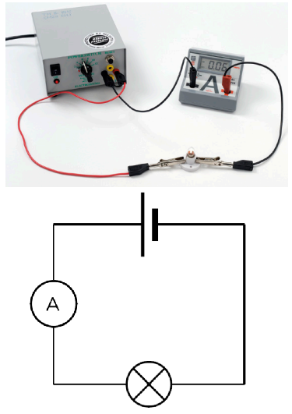

**I = q = neqe**

**t t**

-Current is measured using an ammeter, or a multimeter on its ammeter setting

-An ammeter must be connected in series (in line) with the component it is measuring the current through, as it is measuring the rate of flow of charge through that point in the circuit

**Work and energy in circuits**

-As current flows through a circuit, electrical energy (potential energy) is converted into other forms as work is done by the components in the circuit

-The work done is equal to the energy transformed

-This energy can be calculated from the potential difference and current in a circuit

-Potential difference (V) between two points in a circuit is a measure of the difference in electrical potential energy per coulomb of charge between the two points

-As V = E / q, rearranging the formula allows us to calculate the change in electrical energy (which is equal to the energy transformed/ the work performed) using E = Vq

-The total charge that has moved past a point in the circuit (q) can be calculated from the current and the time that the circuit has been running, as rearranging the current equation (I = q / t) to solve for charge gives q = It

-Combining these two formulae gives the formula for energy transformed/work performed by a circuit:

**E = VIt** where E is energy (J), V is potential difference (V),

I is current (A) and t is time (s)

**Power in circuits**

-Power is the rate at which work is done or energy is transformed

**P = W = E = VIt = VI** where P is power in watts (W), W is work (J),

**t t t** E is energy (J), V is potential difference (V),

I is current (A) and t is time (s)

-Another way to think about the relationship between power, voltage and current is that power is a measure of the amount of electrical energy transformed by the circuit each second, current is a measure of how many units of charge pass a point in the circuit each second and potential difference is a measure of the energy transformed by each unit of charge

**Resistance**

**Motion of electrons**

-In a wire that is not connected to a power source, electrons are rapidly moving in all directions and colliding with the atoms around them due to their random motion



-Even though the electrons are moving at a rapid speed due to this random motion, their net velocity of the electrons in the wire is zero as electrons are travelling in all directions equally

-Applying a potential difference to the wire provides the electrons with energy to move though the circuit

-The potential difference has a relatively minor effect on the random motion of any single electron, but by slightly affecting the path of all electrons moving in the wire causes a net movement of electrons from the negative terminal to the positive terminal

-This net movement of charge is what constitutes an electric current

**Resistance**

-Resistance is a measure of how hard it is for current to flow in a material

-For electrons to flow in a material, outer shell electrons need to be separated from their atoms and given energy to move

-In materials with a low resistance (conductors), very little energy is required to do this, but materials with a high resistance (insulators) require more energy

-Resistance can be though of as a measure of how much potential difference is needed to induce a given current in a material

-Resistance is measured in ohms (Ω)

**Ohm’s Law**

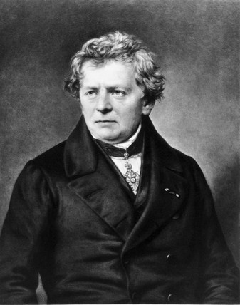

-The unit of resistance is named after Georg Ohm, who discovered that for a given wire at a constant temperature, the current in the wire was directly proportional to the potential difference applied (V $∝$ I)

-The higher the potential difference supplied to the electrons in a circuit, the more energy is provided to the electrons and the higher the current will be

-If the same potential difference is applied to two wires, any differences in current must be due to differences in the resistance of the two wires

-The unit of resistance, the ohm (Ω) is defined as the electrical resistance between two points of a conductor that will result in a current of 1 A being conducted though the conductor when a potential difference of 1 V is applied across the two points

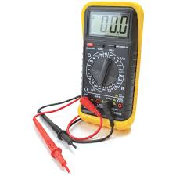

-Ohm’s Law describes the mathematical relationship between voltage, current and resistance

**V = IR** whereV is potential difference (V),

I is current (A) and R is resistance (Ω)

-Resistance can be measured using a multimeter

**Ohmic & non-ohmic conductors**

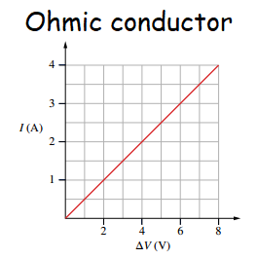

-Ohmic conductors are those whose resistance remains constant when the potential difference applied to them is altered

-They are referred to as Ohmic, as they appear to obey Ohm’s Law; the current they transmit is directly proportional to the potential difference applied

-When the current transmitted by the conductor is plotted against the potential difference applied, a straight line is produced

-The resistance of the conductor can be calculated by dividing the potential difference at any point on the line by current the at that point (or taking the inverse of the gradient)

-Non-ohmic conductors are those whose resistance changes when the potential difference applied to them is altered

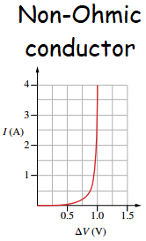

-They do not appear to obey Ohm’s Law as the current they transmit is not directly proportional to the potential difference applied

-The gradient of an I vs V plot is not a straight line for non-ohmic conductors

-While the resistance of an ohmic conductor can be calculated by taking the inverse of the gradient of an I vs V plot, you cannot do this for a non-ohmic conductor

-The non-linear shape of the plot means that the gradient of the line is not always equal to the numerical value of V/I at that particular potential difference

**Resistors**

-Ohmic conductors are called resistors



-Resistors are used to control the current flowing through circuits

-If too much current flows in a circuit, it can damage the components in the circuit or present a safety risk

-Adding a resistor with an appropriate resistance makes it harder for current to flow, reducing the current to the desired level



-Calculations involving voltage, current and resistance can be performed using Ohm’s Law (e.g. finding the value of a resistor required to limit the current in circuit to a given value using R = V/I)

-Resistors are often very small, so their resistance is shown using a colour code, rather than by printing the numerical value on the resistor

**Series and Parallel Circuits**

-The circuits that exist in electronic devices are much more complex that those we have looked at so far, with multiple separate branches all containing different components

-To understand how potential different, current and resistance are distributed through the different branches of the circuit

-To do this, we need to understand the two basic types of circuits, series and parallel circuits

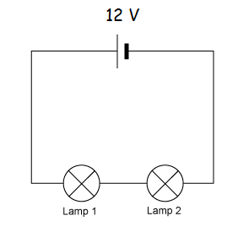

**Series circuits: current flow**

-Components are considered to be in series with one another if they are part of the same closed loop

-In a series circuit, all components are arranged one after the other within the same circuit

-All of the current passes through all components of the circuit, as there is only one path that electrons can travel through the circuit (e.g. if 2 A of current was flowing in the circuit to the right, the whole 2 A would flow through both globes in the circuit)

**The current in a series circuit is the same in all parts of the circuit**

-e.g. for a series circuit with n components:  **IT = I1 = I2 = I3 = …… = In**

**Series circuits: potential difference**

-The potential differences in a series in a series circuit can be calculated using Kirchhoff’s loop rule, which states

**Kirchhoff’s loop rule:** The energy given to the charges (potential gain) must be equal to the energy lost by the charges (potential drop). In a series circuit, the energy loss will be spread between the components of the circuit.

-This law is essentially a reworded version of the law of conservation of energy, e.g. the energy a charge provides the components in a circuit cannot exceed the energy provided to the charge by the battery powering the circuit

-The voltage supplied by the power supply is split between the components (e.g. each of the globes in the circuit to the above right would receive 6 V)

-Voltage in series circuits can be calculated using

**VT = V1 + V2 + V3 + ……+ Vn** where VT is the total potential drop in the circuit and V1, V2 etc. are the voltage drops across each component in the circuit

**Series circuits: equivalent resistance**



-The total resistance in a series circuit is the sum of the resistances of the components in the circuit

-This is because each electron has to pass through every component that provides resistance (e.g. in the circuit to the right the, the total resistance would be 100 +200 + 300 = 600 Ω)

-The circuit would behave identically if the three resistors were replaced with a 600 Ω resistor

-When considering circuits, it is often necessary to simplify them by replacing multiple resistors with a single resistor of **equivalent resistance** to allow us to use Ohm’s Law to calculate the potential difference and current in the circuit

**Equivalent resistance:** The resistance of a single resistor that could be used to replace all other resistors in a circuit so that the same applied potential difference would result in the same current in the circuit

-Equivalent resistance is often called total resistance (RT)

-The formula for calculating resistance in a series circuit is: **RT = R1 + R2 + R3 +……**

**Drawbacks of series circuits**

-Series circuits are simple to construct, but are not widely used in electrical appliances because of the following problems:

-Every time a new component is added, the voltage provided to the other components will decrease (e.g. all bulbs will become dimmer every time a new bulb is added)

-Any break in the circuit (e.g. a blown bulb) will stop all current flowing in the circuit

-Any switch installed in the circuit will affect all components (it is not possible to control the bulbs in the circuit separately)

**Parallel circuits: current flow**

-In a parallel circuit, each component is contained in its own branch of the circuit

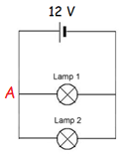

-Because each electron can only travel along one of the different paths, the total current is split between the different branches of the circuit (e.g. if the total current in the circuit to the right was 8 A, each globe would receive 4 A if they had the same resistance)

-The total current flowing in a parallel circuit is the sum of the current flowing in each branch:

**IT = I1 + I2 + I3 + …… + In**

-This is an application of Kirchhoff’s junction rule, which describes how current behaves at the junctions of wires in a circuit

**Kirchhoff’s junction rule: The total amount of current flowing into a junction must be the same as the current flowing out of a junction**

-In the circuit above, there was 8A of conventional current flowing from the positive battery terminal to junction A and 8A flowing out of terminal A (4A in each branch)

-Kirchhoff’s junction rule is a consequence of the fact that the charges moving in the circuit cannot be created or destroyed (conservation of charge)

**Parallel circuits: potential difference**

-In a parallel circuit, each charge passes through only one branch of the circuit

-This means that each charge supplies its full voltage to that branch of the circuit e.g. in the circuit above, both lamps will receive the full 12 V

-For a parallel circuit with n branches: **VT = V1 = V2 = V3 = …… = Vn**

**Parallel circuits: equivalent resistance**

-The total resistance is calculated differently in a parallel circuit, as each electron only has to pass through one of the branches of the circuit that provides the resistance

-Every time another path is added, it provides another path for electrons, lowering the total resistance in the circuit

-The equivalent resistance in a parallel circuit is calculated using the formula:

**1 = 1 + 1 + 1 +…… 1**

**RT R1 R2 R3  Rn**

e.g. in the circuit on the previous page, if each globe has a resistance of 3 Ω

1 = 1 + 1 = 1 + 1 = 2 If 1 = 2 , then RT = 3 = 1.5 Ω

Rt R1 R2 3 3 3 RT 3 2

**Differences between series and parallel circuits**

-Parallel circuits have a number of advantages over series circuits including:

-Adding extra components does not affect the voltage received by the components on the other branches of the circuits (each branch receives the full voltage)

-If there is a break in the circuit, current only stops flowing in that branch of the circuit (e.g. if one bulb blows, the rest will remain on)

-Because of this it is possible to control individual components with their own switches

-For these reasons, parallel circuits are more widely used in appliances etc.

**Calculation summary for series and parallel circuits**

|  |  |  |
| --- | --- | --- |
|  | **Series** | **Parallel** |
| Current (I) | IT = I1 = I2 = I3 = …… = In | IT = I1 + I2 + I3 + …… + In |
| Potential Difference (V) | VT = V1 + V2 + V3 + ……+ Vn | VT = V1 = V2 = V3 = …… = Vn |
| Resistance (R) | RT = R1 + R2 + R3 + …… + Rn | 1 = 1 + 1 + 1 +…… 1  Rt R1 R2 R3  RT |

**Complex Circuits**

-In reality, most electrical circuits and appliances have some components in series and others in parallel with one another

-Voltage is split between components in the series parts of the circuit and current is split in the parallel parts

-Equivalent resistance can be calculated using RT = R1 + R2­ + R3 + …. Rn for the series parts of the circuit and 1/RT = 1/R1 + 1/R2­ + 1/R3 + … 1/Rn for the parallel parts of the circuit

e.g. to find the total current and resistance this circuit:

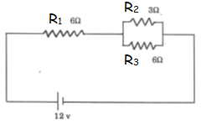

-Equivalent resistance in the parallel part can be calculated as for parallel circuits

1/R2+3 = 1/R2 + 1/R3­ = 1/3 + 1/6 = 2/6 + 1/6 = 3/6

If 1/RT = 3/6, RT = 6/3 = 2 Ω

-The total resistance in the circuit can now be calculated using the series formula for series circuits

RT = R1 + R2+3 = 2 + 6 = 8 Ω

-Once the total resistance is known, the total current can be calculated using Ohm’s Law

I = V/R = 12/8 = 1.5 A

**Power in series and parallel circuits**

-Power used by an electrical component is calculated by **P = VI**

-Parallel circuits have a lower resistance than a series circuit containing the same components, so they have a greater overall current

-This means that components will draw a greater amount of power in a parallel circuit

-Note that as  **P = VI**  and **V = IR, P = (IR) I**, so **P = I2R**

-Also,  **P = VI**  and **I = V , P = V(V) , so P = V2**

**R R R**

-This formula makes it possible to calculate the power a component uses without knowing the voltage drop across the component or without knowing the current, as long as the other factor is known

**Electricity in the home**

**Alternating and Direct Current**

-The current provided by a battery is direct current (DC)

-In DC current, charges only flow in one direction, from the positive terminal of the battery to the negative terminal (electron flow is only in the opposite direction

-The current in household wiring is known as alternating current (AC)

-In AC current the direction of electron flow changes several times a second

-AC current is used for household electricity as it is easier to generate and transmit and its voltage can be altered using a transformer

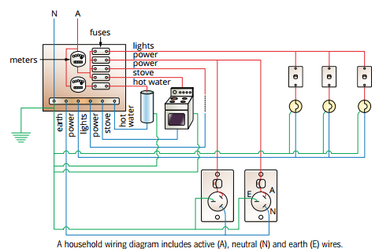

**Household Wiring**

-Household wiring is essentially a massive parallel circuit with separate switches controlling every branch of the circuit

-In Australia household electricity is 240 V 50 Hz AC, which means it has an average voltage of 240V and that the current changes direction 50 times per second

**Measuring household electricity consumption**

-Energy consumption is normally measured in Joules

-Energy can be calculated by multiplying power use (e.g. the rate of energy use per unit of time) by time

-As such, units of energy are equivalent to a unit of power multiplied by a unit of time

(e.g. 1 J = 1 Ws)

-Household energy consumption on power bills is measured in kilowatt hours (kW h), where

1 kW h = 1000 W x 3600 s = 3.6 x 106 W s = 3.6 MJ

**Electrical safety in the home**

-Because the voltage of household electricity is capable of generating large currents, there are several safety features that are used to prevent deaths and injuries due to electrocution

**3 pin wiring**



-Household appliances have three-pins for connecting into the houses electrical circuit, even though only two pins are required to make a complete circuit

-The active and neutral pins and wires exist to complete the circuit and the earth pin is a safety feature

-**Active (brown wire)**: carries current from power point to appliance

-**Neutral (blue wire)**: carries current from appliance back to power point, completing the circuit

**-Earth (green/yellow wire)**: connects the power point and anything connected to the earth wire to the ground

-Normally the metal casing of an appliance is connected to this wire

-If the wiring in an appliance breaks, causing the casing to become electrified, the current can flow through the earth wire into the ground, instead of flowing through anyone that touches the appliance

**Fuses and circuit breakers**

-If there is a problem with an electrical appliance, this can cause an abnormally high current to flow

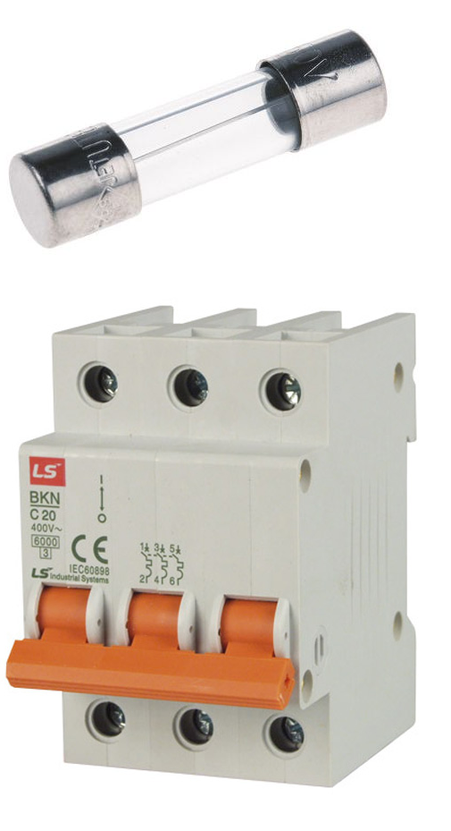

-This generally happens in the event of a short circuit

-If the insulation between the active and neutral wires fails and the wires come into direct contact, it forms a path of very low electrical resistance between the active and neutral plugs

-As I = V/R, the decrease in resistance can induce a very high current, causing the circuit to become overloaded

-High currents can present an electrocution risk, damage electrical appliances and generate large amounts of heat, potentially causing electrical fires

-All household circuits contain a fuse, or a circuit breaker designed to immediately shut off current to an overloaded circuit

-Fuses are thin lengths of wire that are designed to burn out if too much current flows through them

-When the fuse wire burns out, it breaks the circuit, preventing the current from flowing

-The thickness of the fuse wire can be altered to alter the current that it can flow before burning out

-A circuit breaker is essentially an electronic fuse

-When too much current flows through it, it strips the switch, breaking the circuit

-Most houses now have circuit breakers instead of fuses, as they do not need to be replaced when they trip

-Fuses are still used in automotive and other applications as they can be made smaller and lighter than circuit breakers

**Residual Current Devices (RCDs/safety switches)**

-Most household circuit boxes contain both circuit breakers and an RCD (safety switch)

-These look very similar to a circuit breaker, but function in a different manner

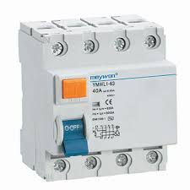

-All current flowing into and out of the house passes through and is measured by the RCD

-If there is any difference between the current going in and out, it indicates that current is leaking to ground, either through a faulty appliance or a person (e.g. being electrocuted)

-The RCD shuts off all power to a house with 0.03 seconds of detecting such a “leak”

**Double-Insulation**

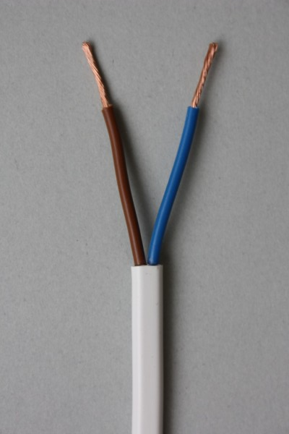

-For an electric current to flow in a material, it needs to have delocalised electrons (e.g. metals like copper in copper wiring) or be/be covered in a solution in which charged ions can flow (e.g. tap water)

-Insulators are substances that are unable to conduct an electric current, such as rubber, plastics and other materials

-Electrical wiring is coated in an insulator to prevent a current flowing from the wire to the ground through a person holding the wire

-Household wiring is double insulated, meaning that each individual wire (active/neutral/earth) is covered in insulating material, then the bundle of wires is covered in another layer of insulator

-This makes it harder for a person to come into contact with a bare wire and to be electrocuted

**Electrocution**

-Electrocution (also called electric shock) occurs when excess electricity flows through the body due to an electrical accident or aa malfunction with an electrical device

-The damage caused by an electric shock depends on the amount of current passing through the body, the duration of the shock and the path it takes through the body

-If a 240V source comes into good electrical contact with the body, the current that will flow through the body to the ground is significantly in excess of that required to cause death

-Human bodies have a high resistance, so the electrical energy entering the body is converted into heat, causing severe internal burns

-It can also interfere with the electrical signals in the nervous system that regulate vital body functions such as heartbeat and breathing

-The amount of electrical energy entering the body depends on the current and its duration, so an increase in either of these will make sever damage or death more likely

-The path of the shock is also important (e.g. a current entering one arm and exiting the other is more likely to cause fibrillation (irregular contraction) of the heart muscles or to damage the muscles that cause breathing)